**IT8118 Advanced Programming Group Project: Semester 2 2023-24**

[Home Services Management System]

Project Document

**Group Members:**

|  |  |
| --- | --- |
| Student ID | Name |
| 202000270 | Amena Almohanna |
| 202002514 | Fedaa Abdulwahab |
| 201901982 | Maryam Alali |
| 202003580 | Sara Abdulrahman |

**Class / Stream:**

|  |
| --- |
| **Class 1 / 001** |

**By submitting this assessment for marking, either electronically or as hard copy, we confirm the following:**

* This assignment is **our own work**.
* Any information used has been properly referenced.
* We understand that a copy of our work may be used for moderation.
* We have kept a copy of this assignment.

Contents

1. Database Design 3

1.1. Database Design Diagram 3

1.2. Database Design Explanation 3

2. Application Demo Users 4

3. Web Application Documentation (w/ Screenshots) 5

4. Windows Form Application Documentation (w/ Screenshots) 17

5. Supporting videos link 22

# Database Design

## Database Design Diagram

To provide a comprehensive overview of our database structure, we have prepared a database diagram which illustrates all the tables, their properties, and their relationships. The diagram serves as a visual representation of our database design, offering clarity on how data is organized and interconnected within our system.

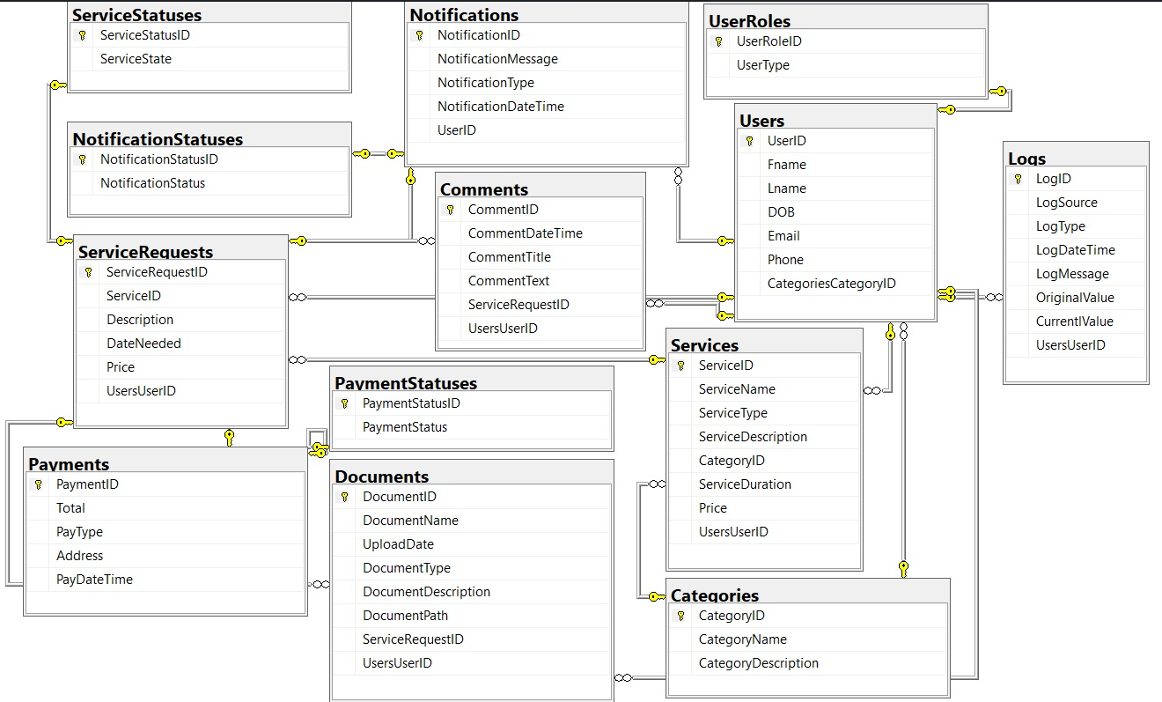

## Database Design Explanation

In our database diagram, we've identified multiple entities based on the provided tables, each serving a specific purpose aligned with the system requirements:

**Category:** This entity represents different categories for services offered by the system.

Properties include CategoryID (primary key), CategoryName, CategoryDescription, and UserID, establishing a relationship with the User entity.

**DocumentLog**: The DocumentLog entity records system logs capturing various events and activities.

Properties include LogID (primary key), LogSource, LogType, UserID (foreign key referencing User), LogDateTime, LogMessage, OriginalValue, and CurrentValue.

**Services**: This entity encapsulates details about the services offered within the system.

Properties include ServiceID (primary key), ServiceName, ServiceType, ServiceDescription, CategoryID (foreign key referencing Category), ServiceDuration, and Price.

**User**: The User entity represents users interacting with the system.

Properties include UserID (primary key), UserRoleID (foreign key referencing Role), Fname, Lname, Email, and Phone.

**Comment, Document, Notification, Payment, ServiceRequest, Status, Kind:** These entities capture additional functionalities such as user comments, uploaded documents, notifications, payment details, and service requests, each with relevant properties mapping to their respective requirements.

# Application Demo Users

* *Provide testing username and password for users seeded or created in your system for testing and demonstration purposes:*

*Form username and password:-*

***Admin:-***

*Username: admin@gmail.com*

*Password: @Admin123*

***Manager:-***

*Username: manager@gmail.com*

*Password: manager*

*Web username and password:-*

|  |  |  |  |
| --- | --- | --- | --- |
| *Demo Username* | *Demo Password* | *User Role* | *Which features / functionality can be tested with this user?* |
| [*Admin1@gmail.com*](mailto:Admin1@gmail.com) | *Admin1@* | *Admin* | *Show users*  *CRUD users*  *Show services*  *CRUD services*  *Show documents*  *CRUD documents*  *Show service status*  *CRUD services status*  *Show service request*  *CRUD services request*  *Show categories*  *CRUD categories*  *Show notification*  *CRUD notification*  *Show comment*  *CRUD comment*  *Show Roles*  *CRUD roles*  *Show Payment*  *CRUD Payment*  *Show Payment Status*  *CRUD Payment Status* |
| *Manager1@gmail.com* | *Manager1@* | *Manager* | *Show services*  *CRUD services*  *Show services Request*  *CRUD services Request*  *CRUD documents*  *CRUD notification*  *CRUD Payment*  *CRUD comment* |
| *Tech1@gmail.com* | *Tech1@* | *technician* | *CRUD ServiceRequest*  *CRUD documents* |
| [*ameena4almuhana@gmail.com*](mailto:ameena4almuhana@gmail.com)  [*s22albuainain@gmail.com*](mailto:s22albuainain@gmail.com) | *4:EmaxR4ksHyDa!*  *Sara1234@* | *Customer* | *Show documents*  *CRUD documents*  *Show services*  *CRUD services*  *Show services Request*  *CRUD services Request* |

# Web Application Documentation (w/ Screenshots)

This the home screen of our application

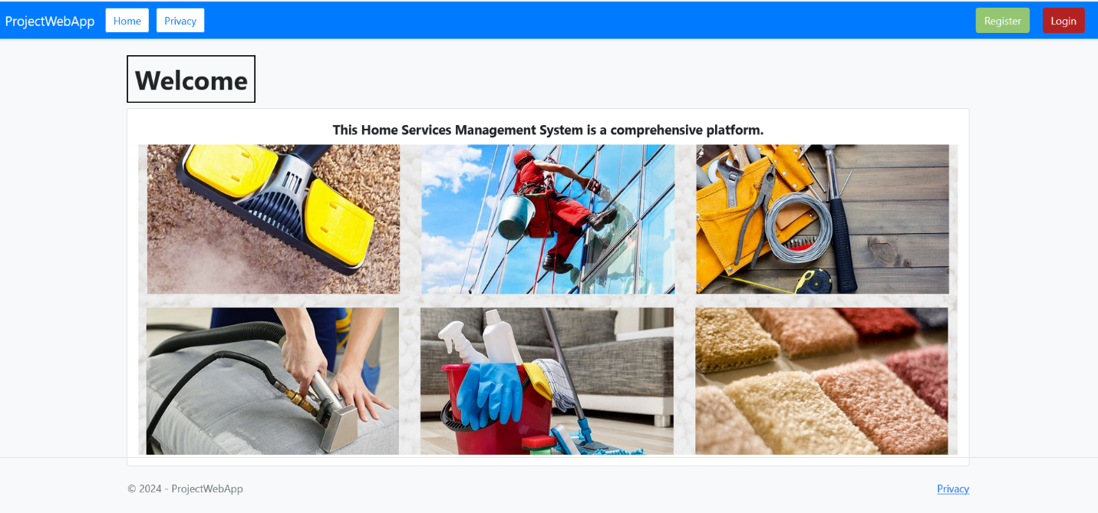

To test our application, we will begin with the Login Interface,

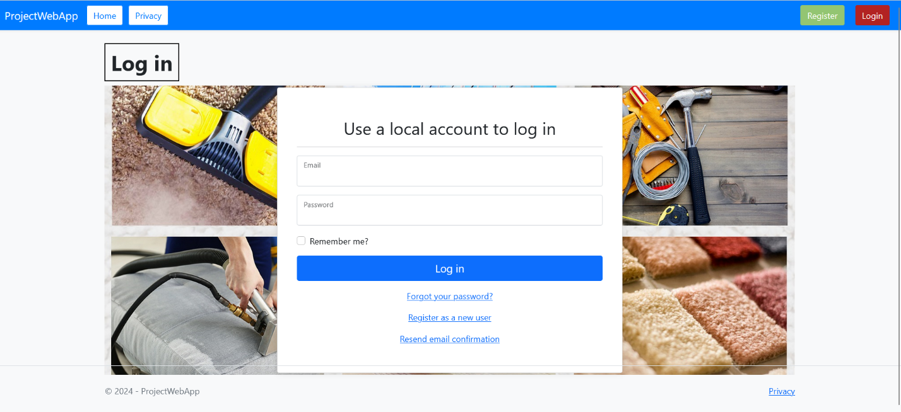

so, when we introduce invalid user or empty input, it will show error message like this:

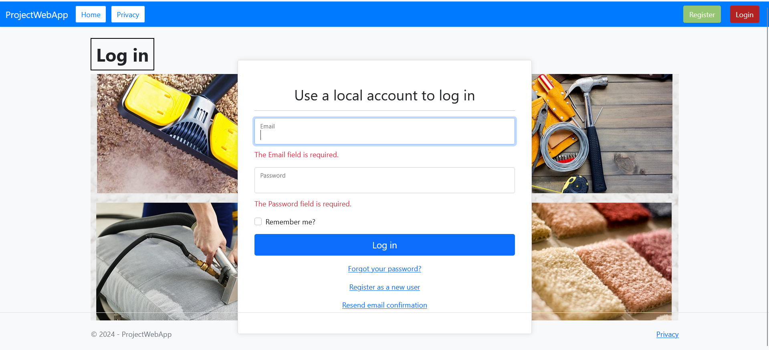

Now, we will try to use the registration page:

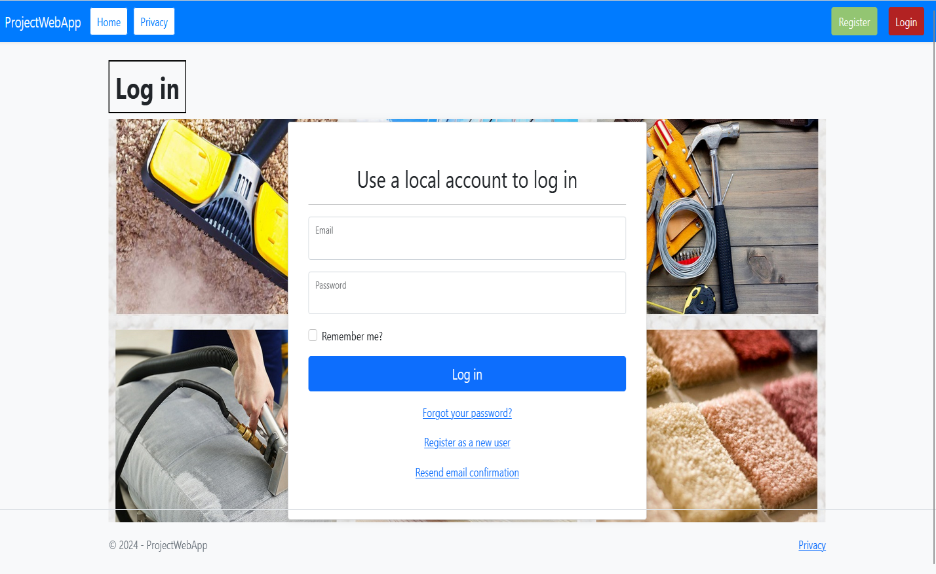

We need to fill all the fields, when we do not put some fields, an error message is shown like:

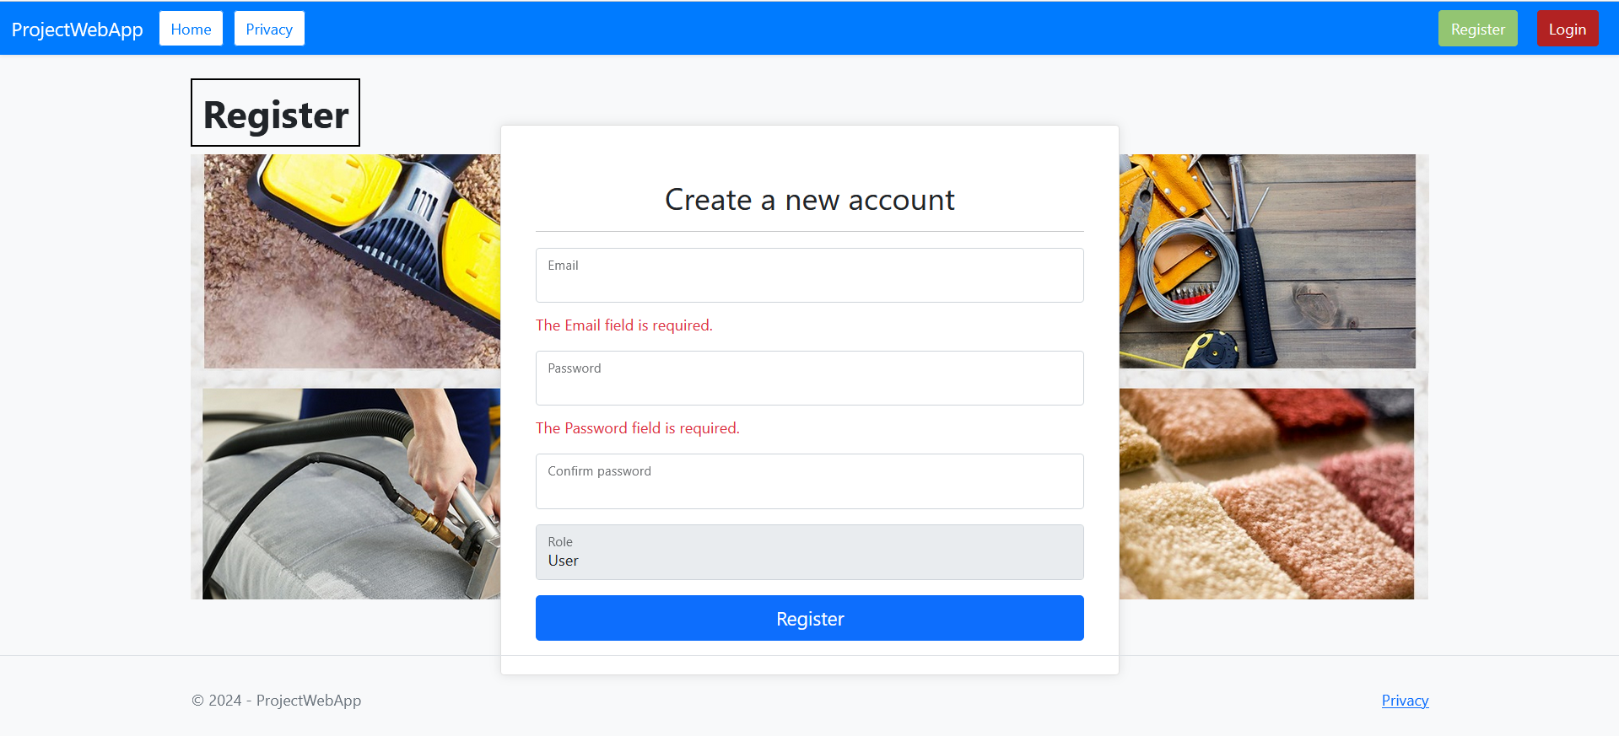

Let’s move the dashboard, so when a user have a successful access, it will be redirected to the home page by his role,

**The home dashboard for Admin role:**

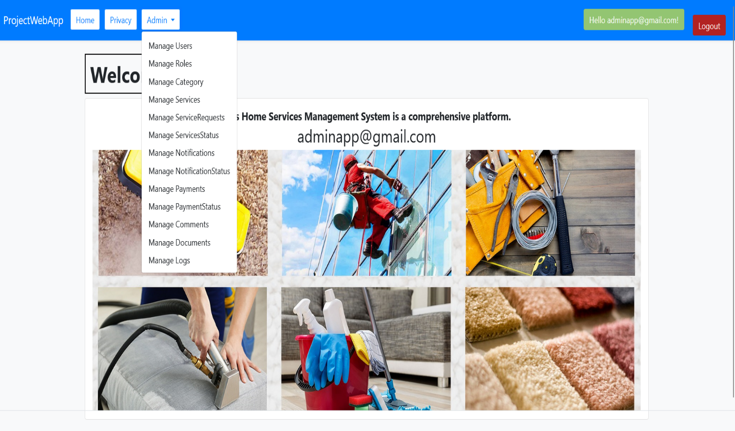

The admin has a full access to the system.

**The home dashboard for Manager role:**

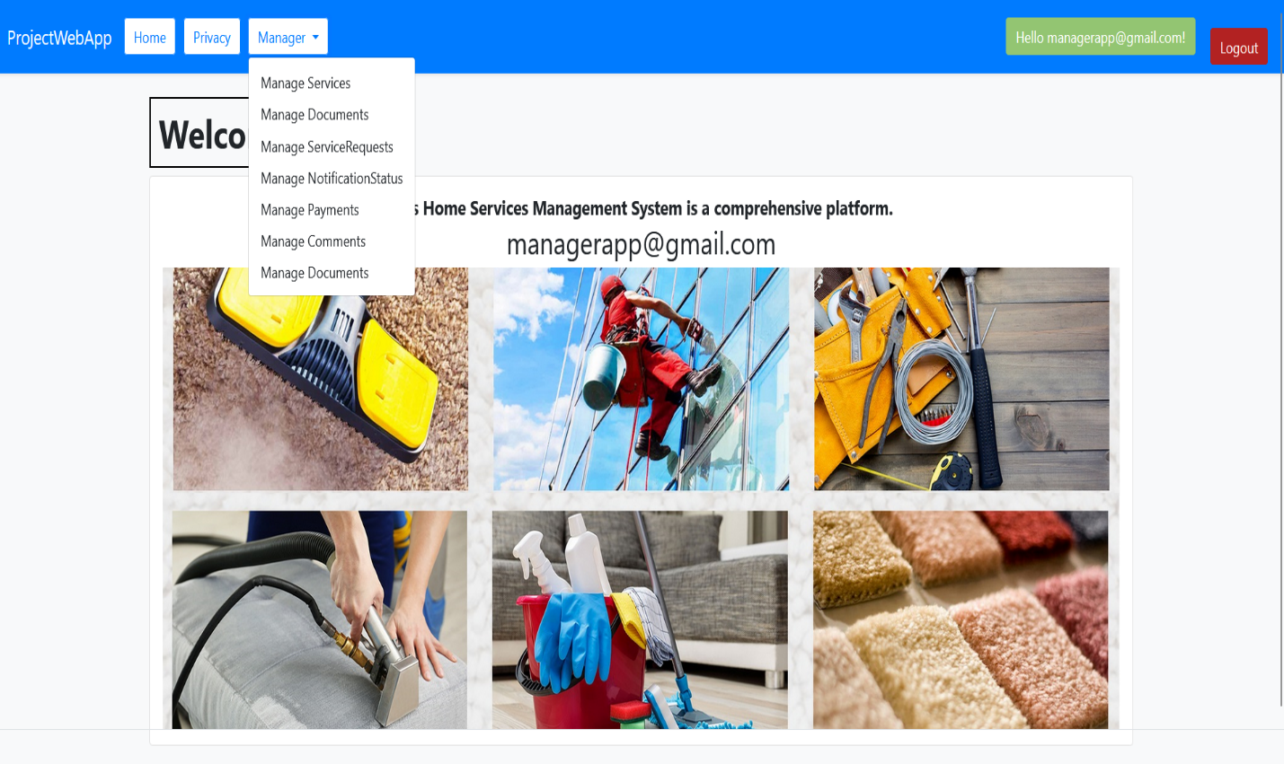

The manager role is limited to the users, the documents, and the services.

**The home dashboard for Technician role:**

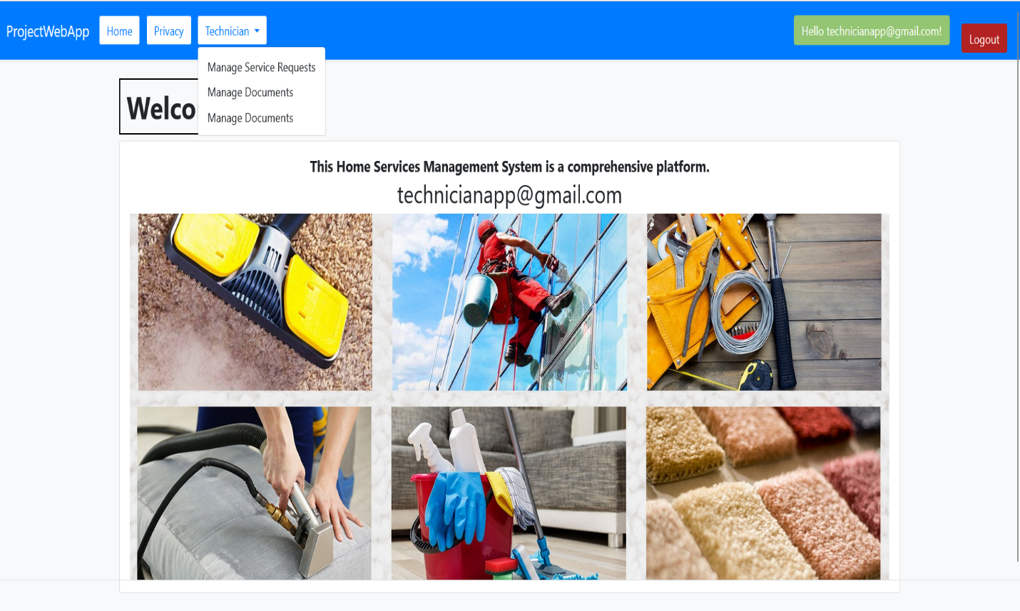

The technician role is limited to the documents.

**The home dashboard for Customer role:**

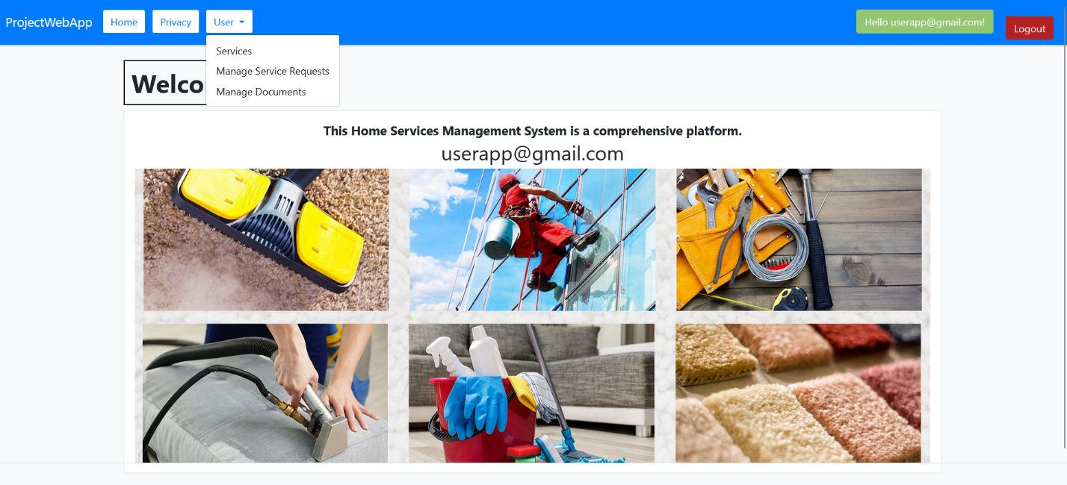

Like the technician, the customer can only access to the documents part of the system.

The section ServicesRequests which are allowed for both the admin and the manager is shown here:

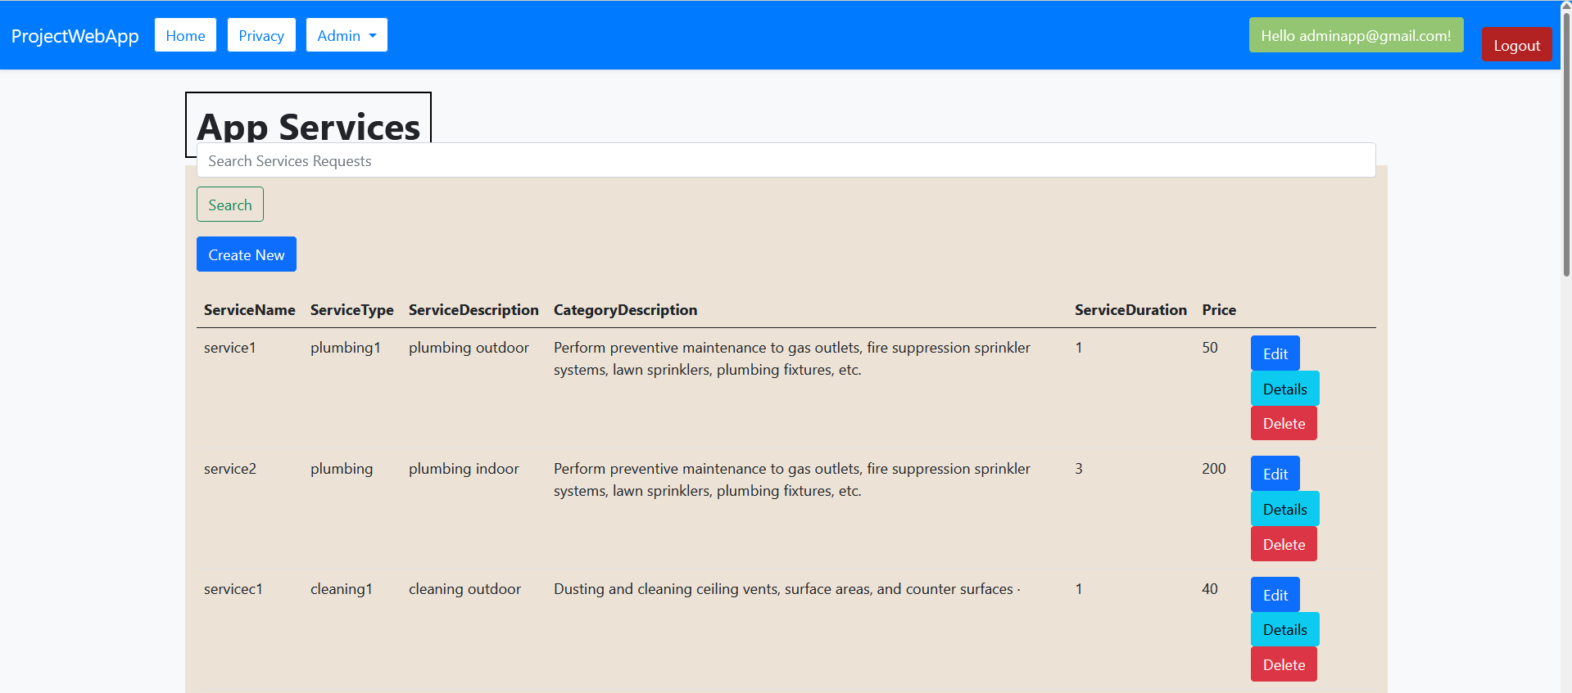

They can manage the list of service Requests by Edit some information and validate or go back to service’s section like this:

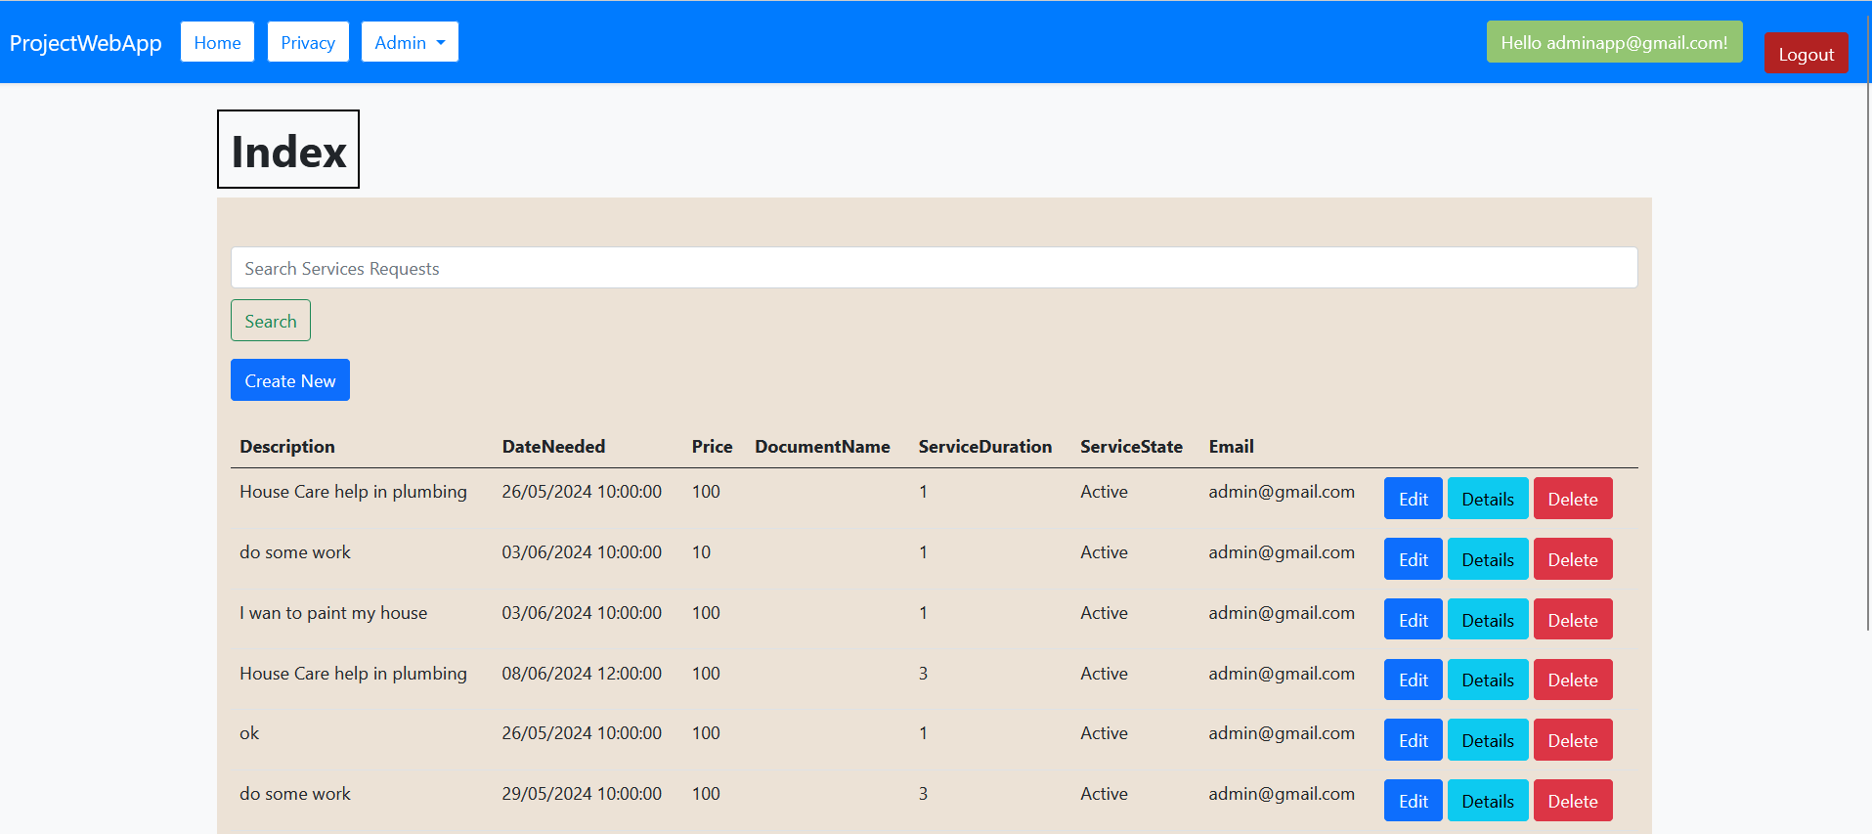

For the administrator It is possible, to show the details of user and go back to the previous page or pass to the Edit page:

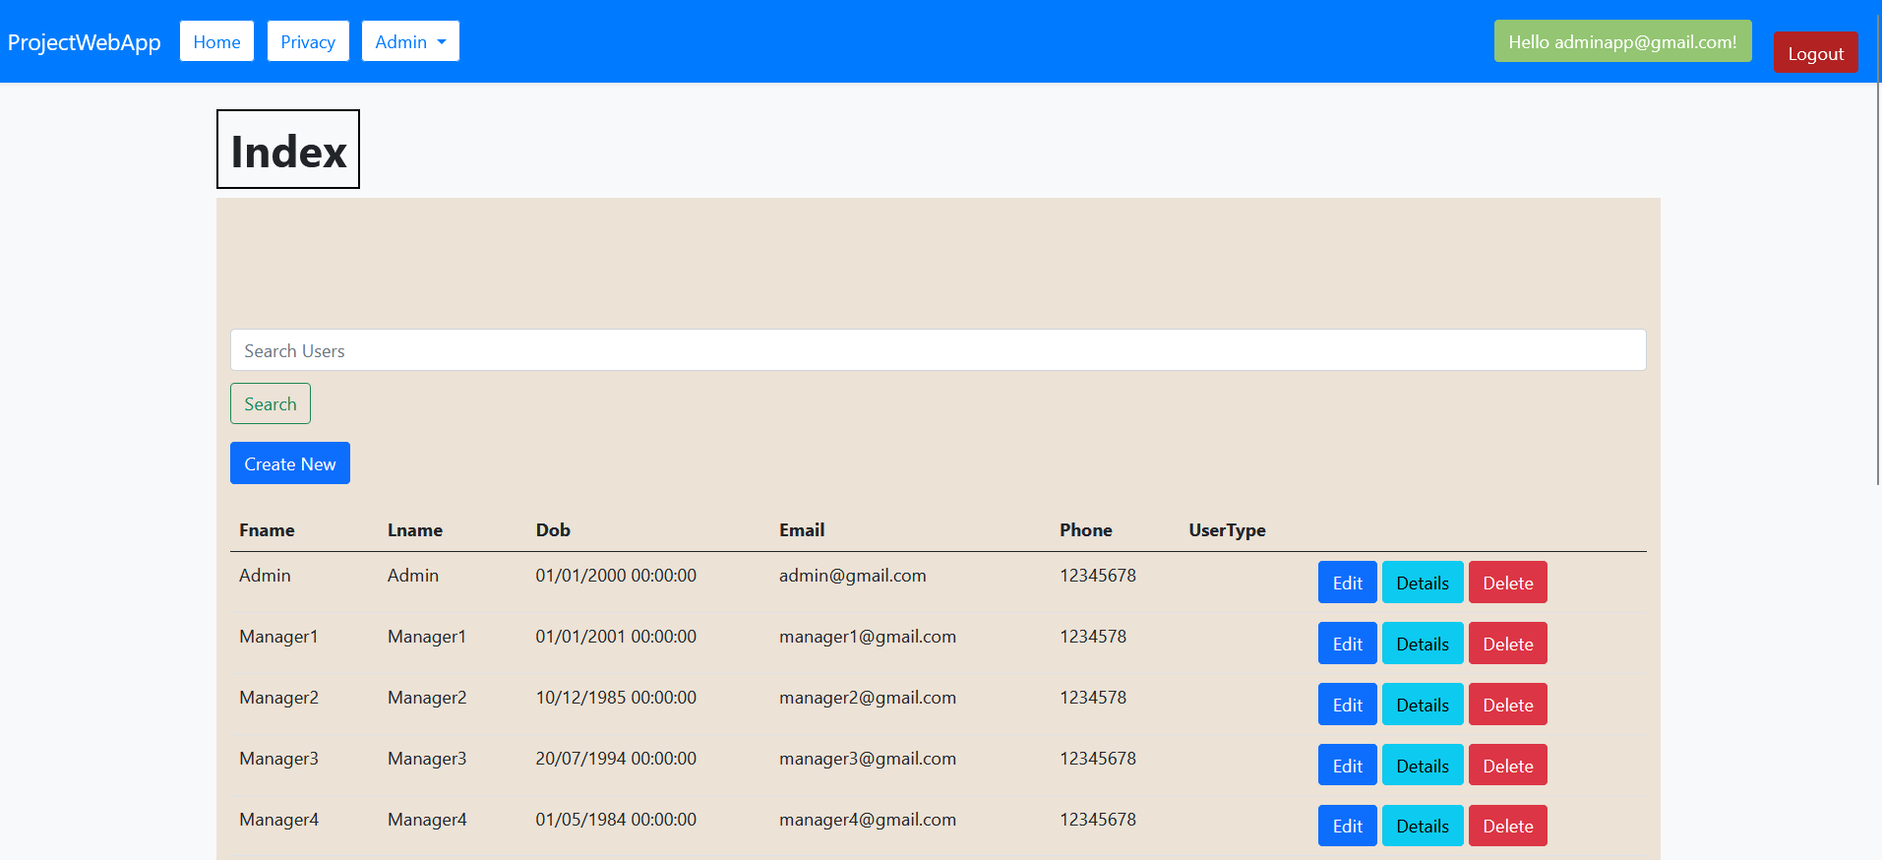

This interface shows the possibility of the admin to create users and edit or delete them form a logic reason:

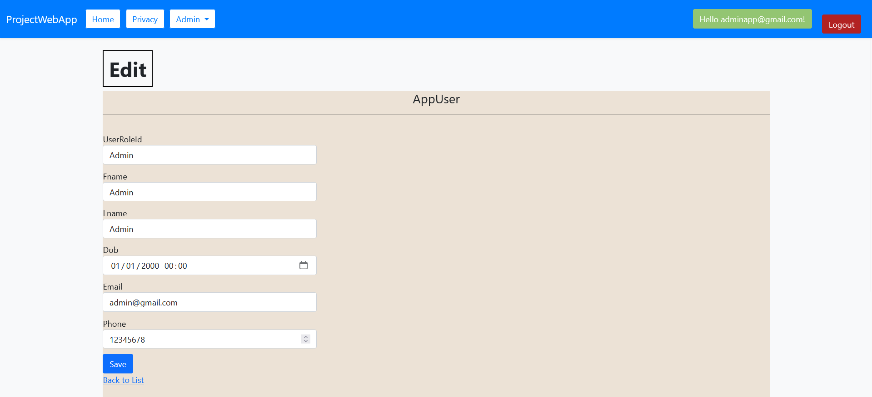

Now the role section, which is strictly by the admin, he can add new role, edit existent one, show details of role and also delete some role.

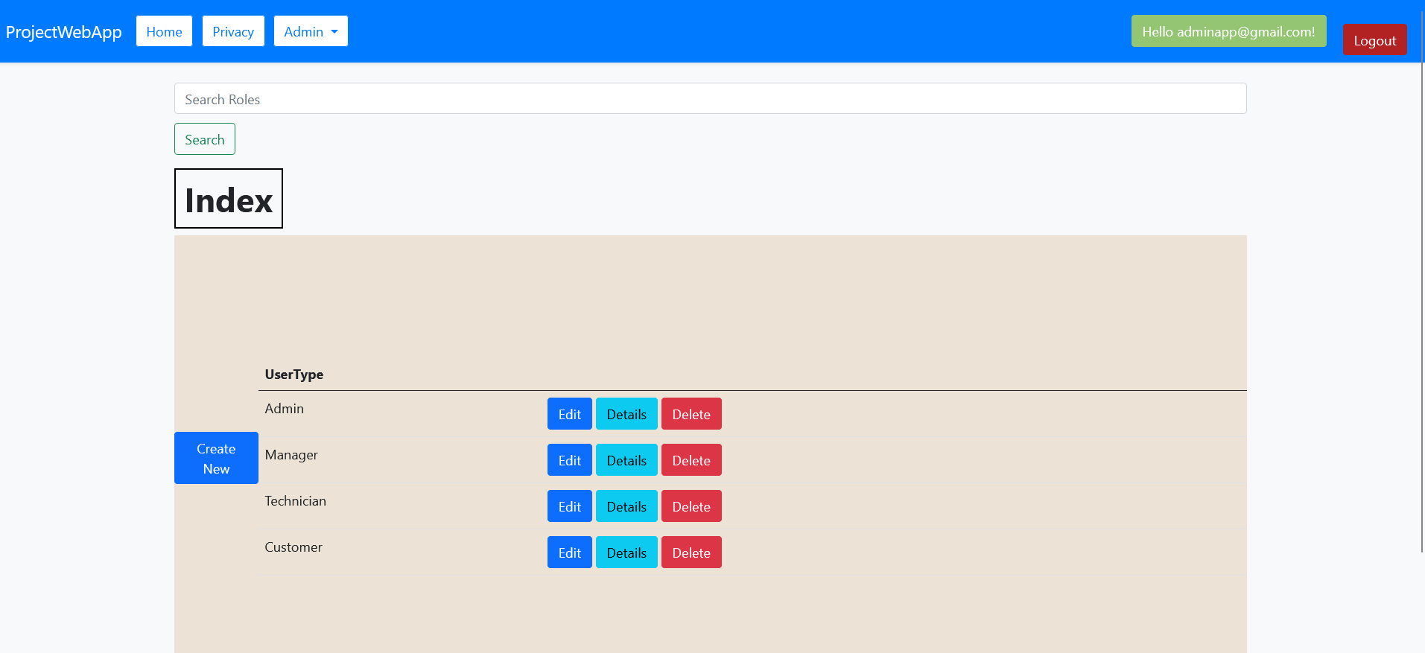

The service status section is allowed to admin, he can show the status of different services and can add services, edit, or delete it.

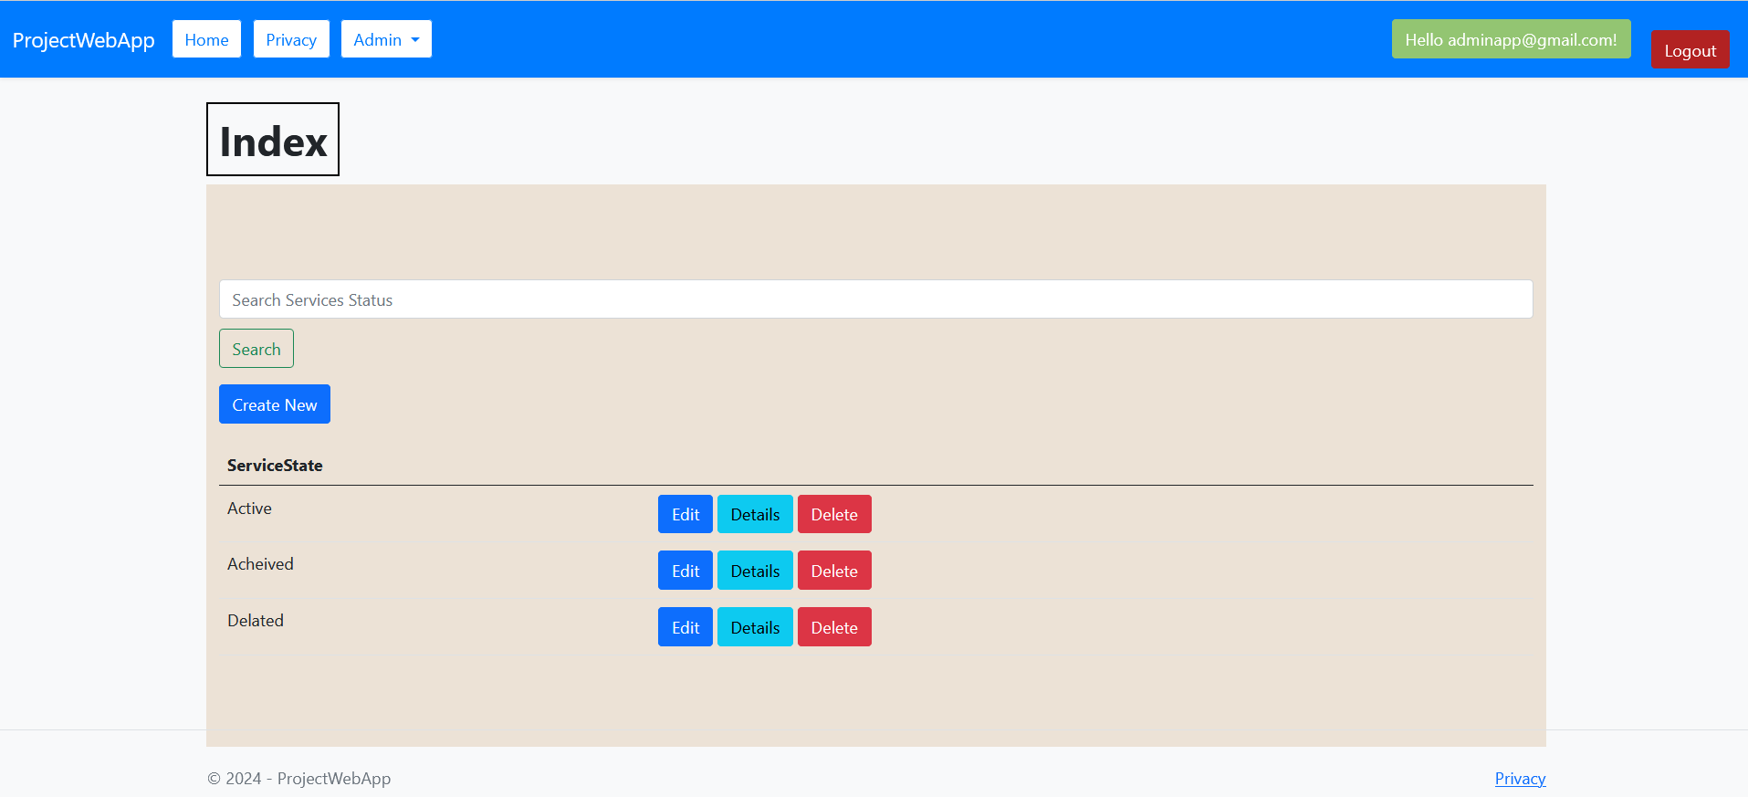

Finally, the notification section, it is allowed to admin, he can create notification and send it to the users.

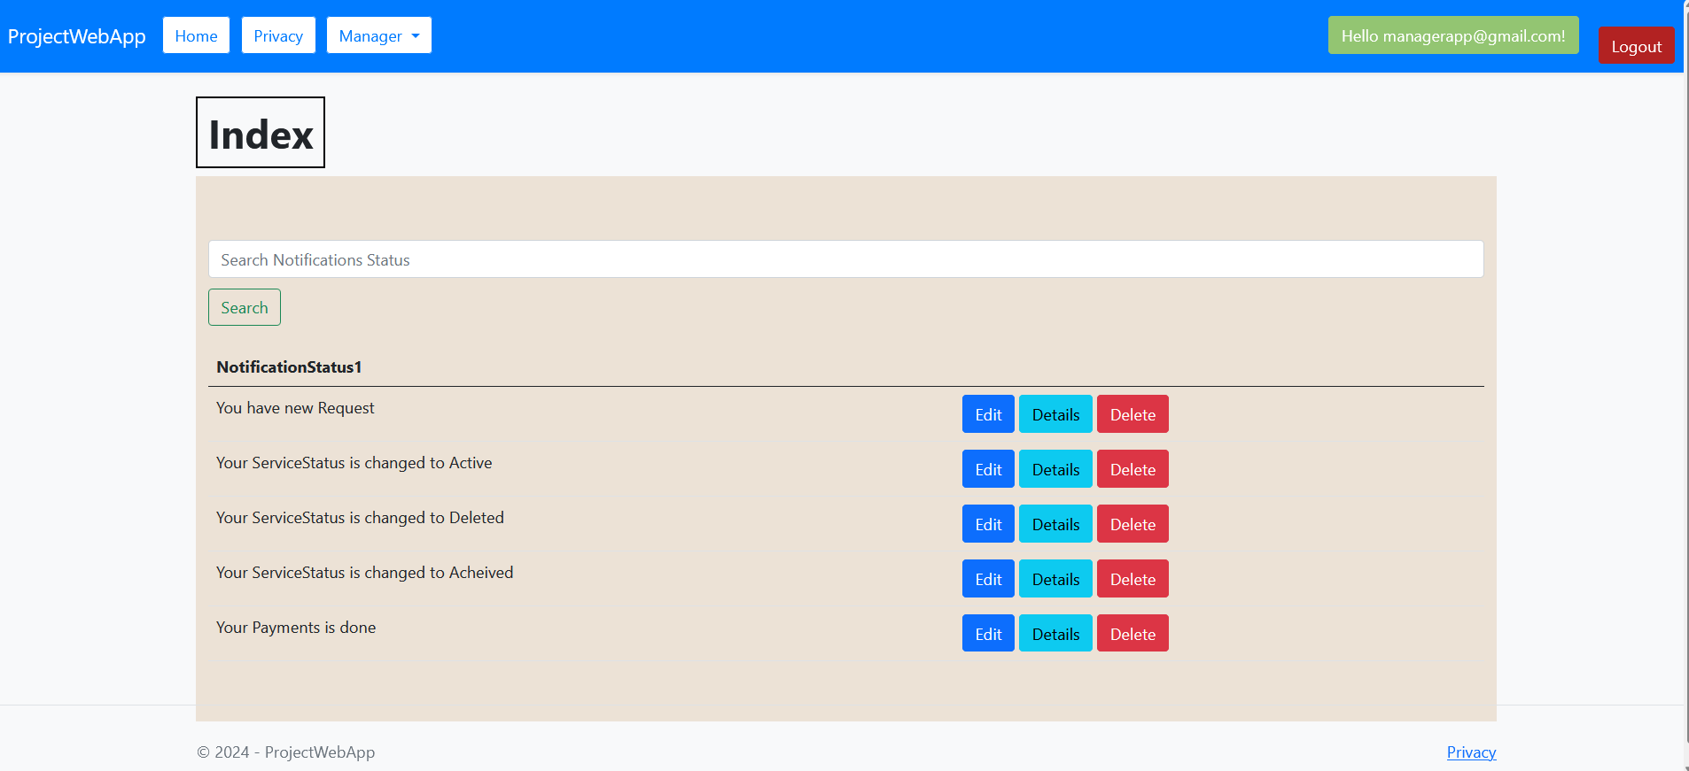

Now we will test the scenario of creating service request and payment by user.

He begins with the choice of category like this:

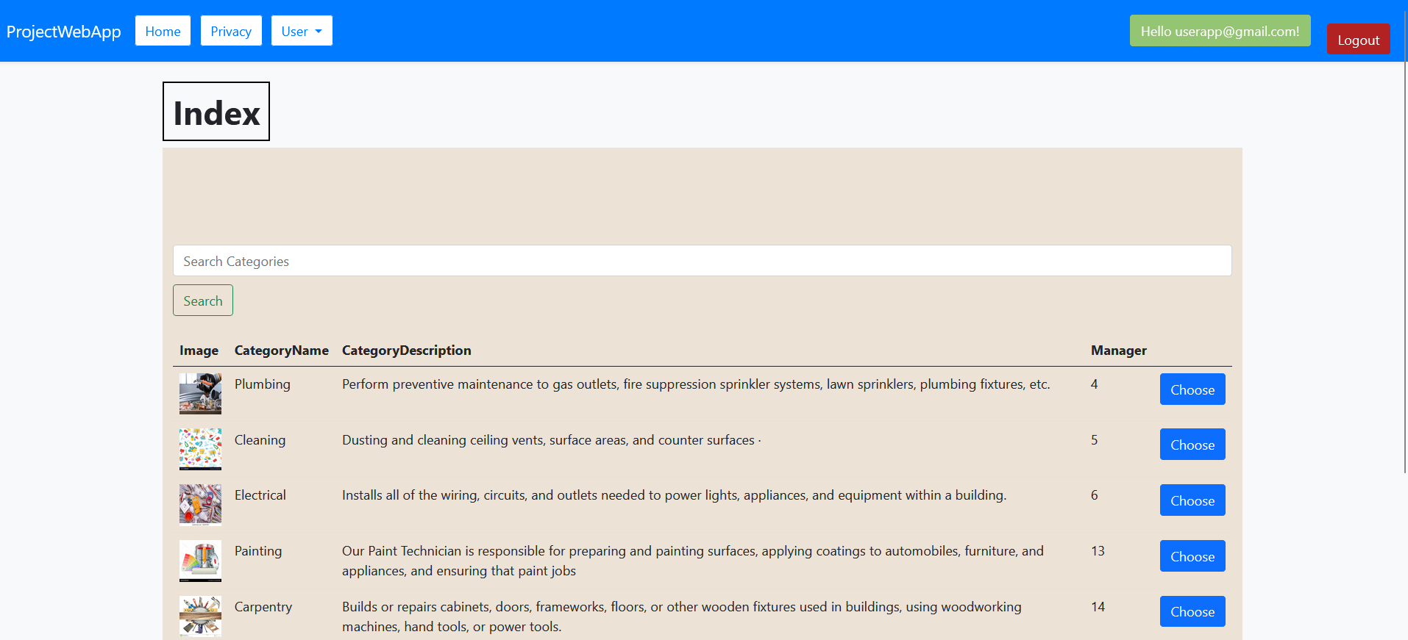

Then he chooses category to pass to this interface:

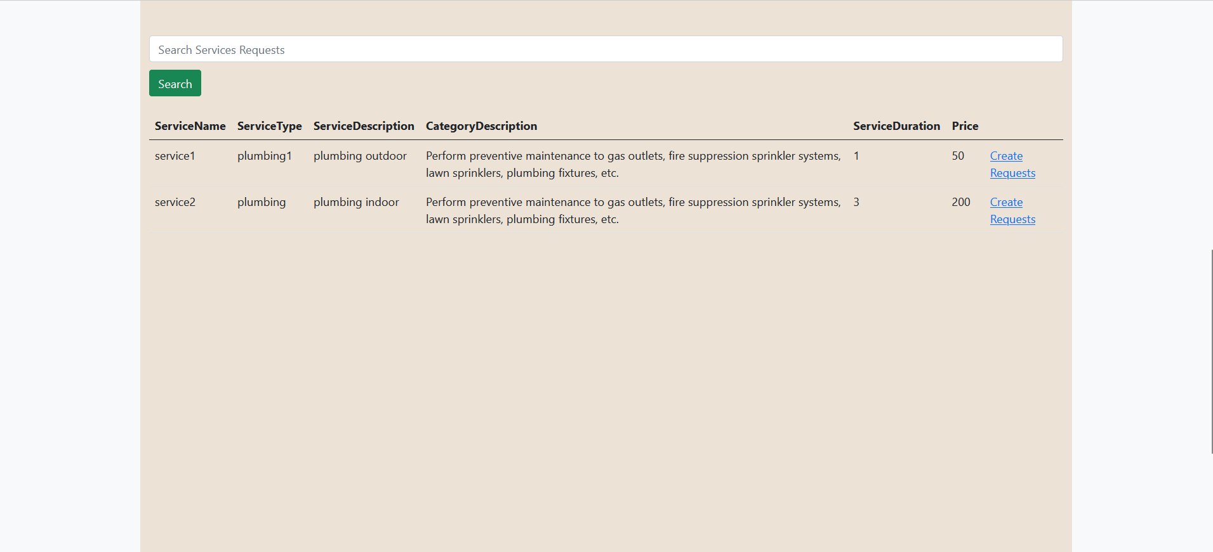

Now it is possible to create service request:

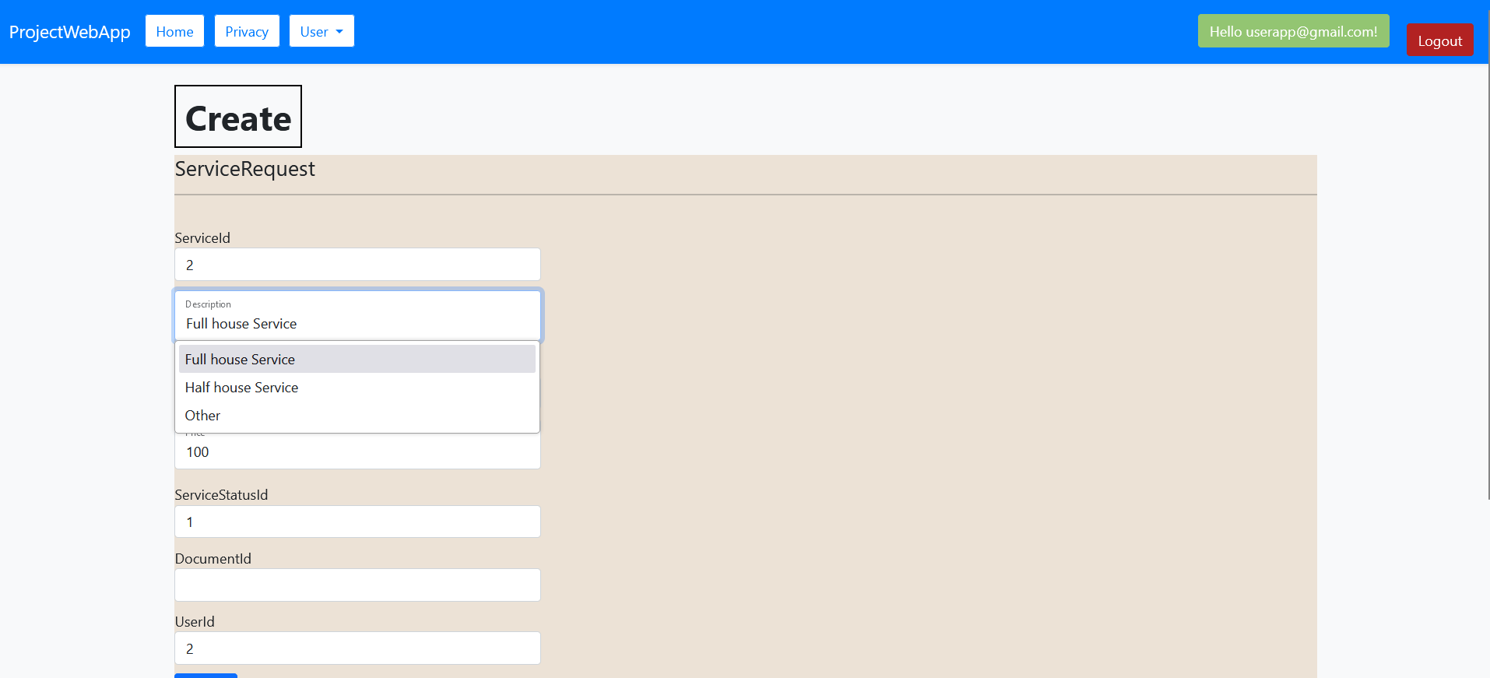

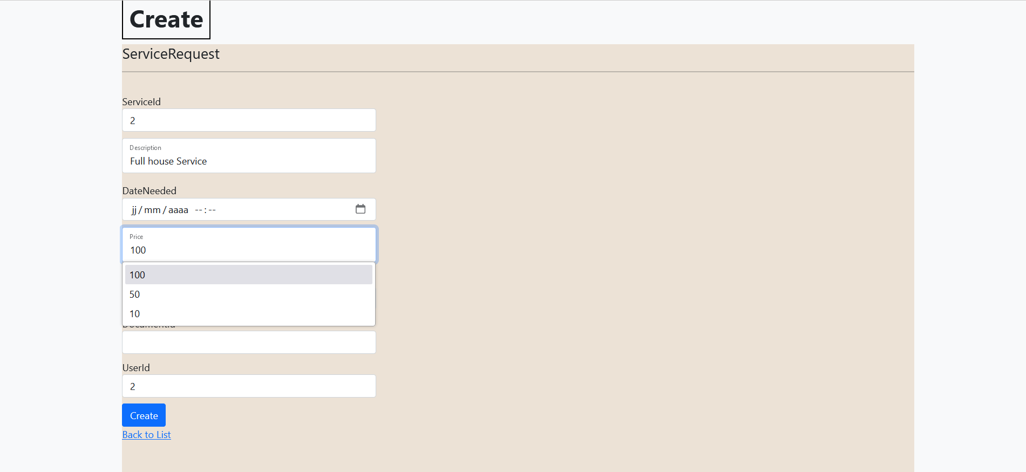

After creation of service request, he proceed to payment:

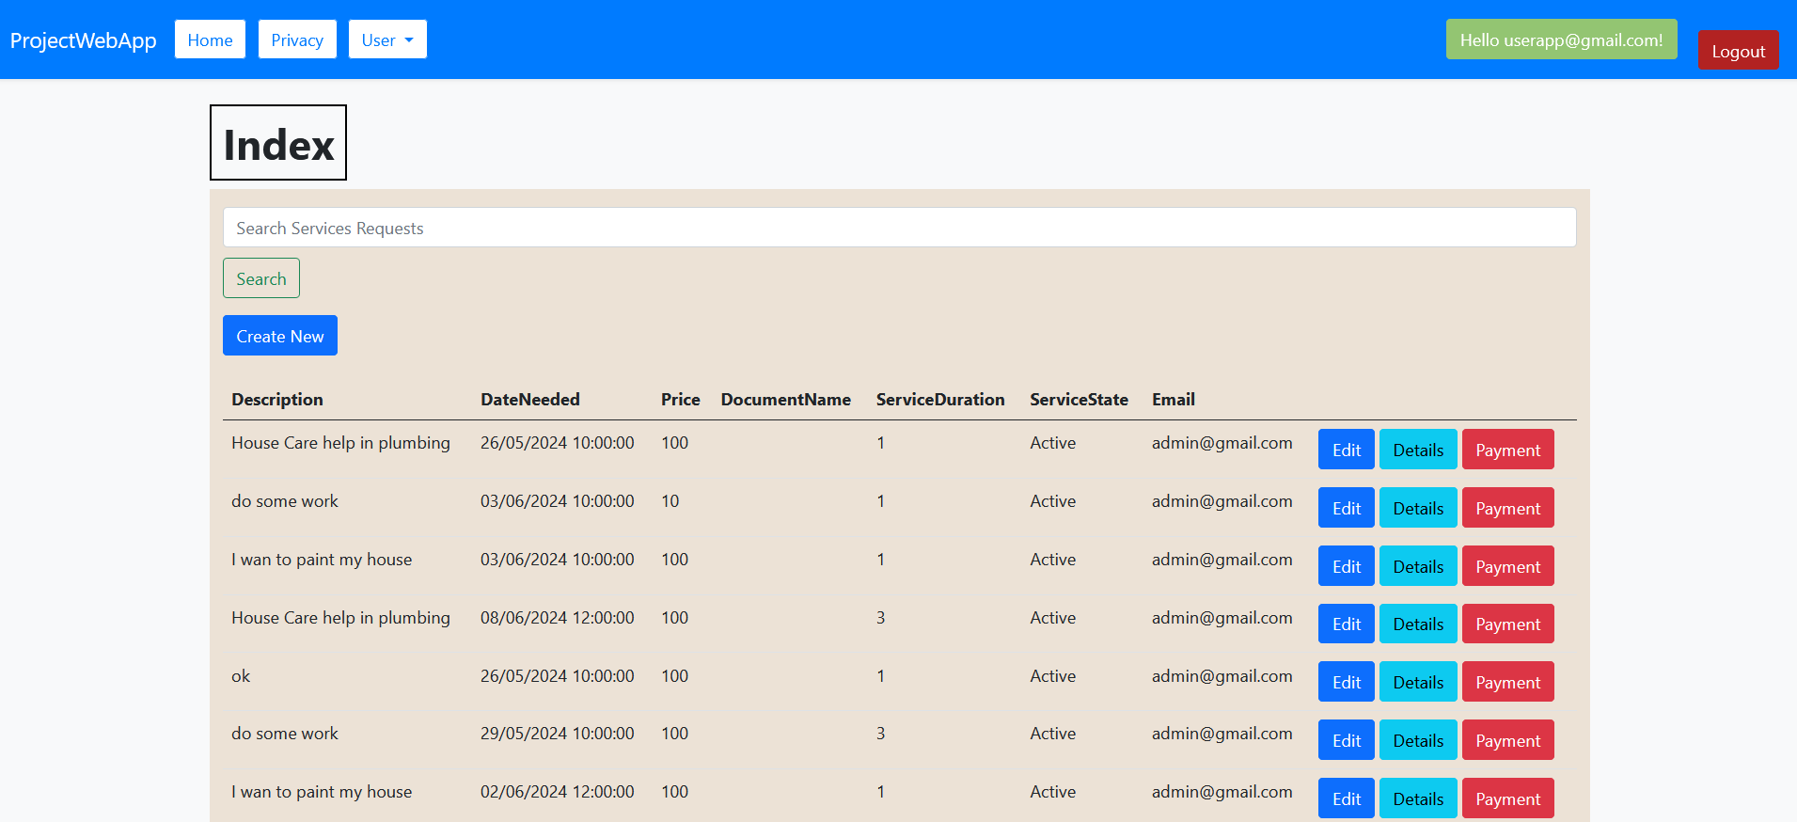

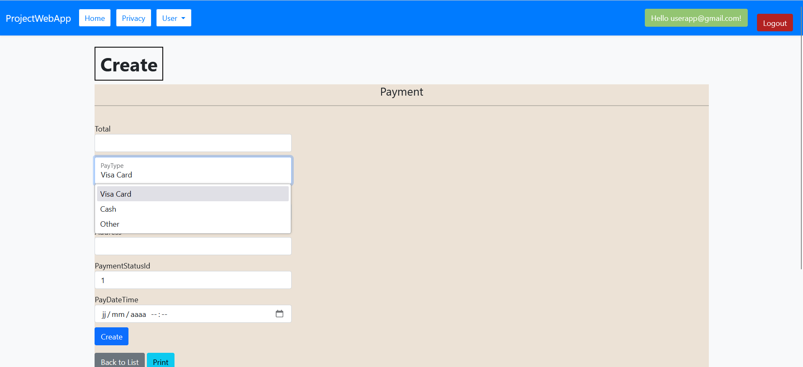

The user can print his invoice:

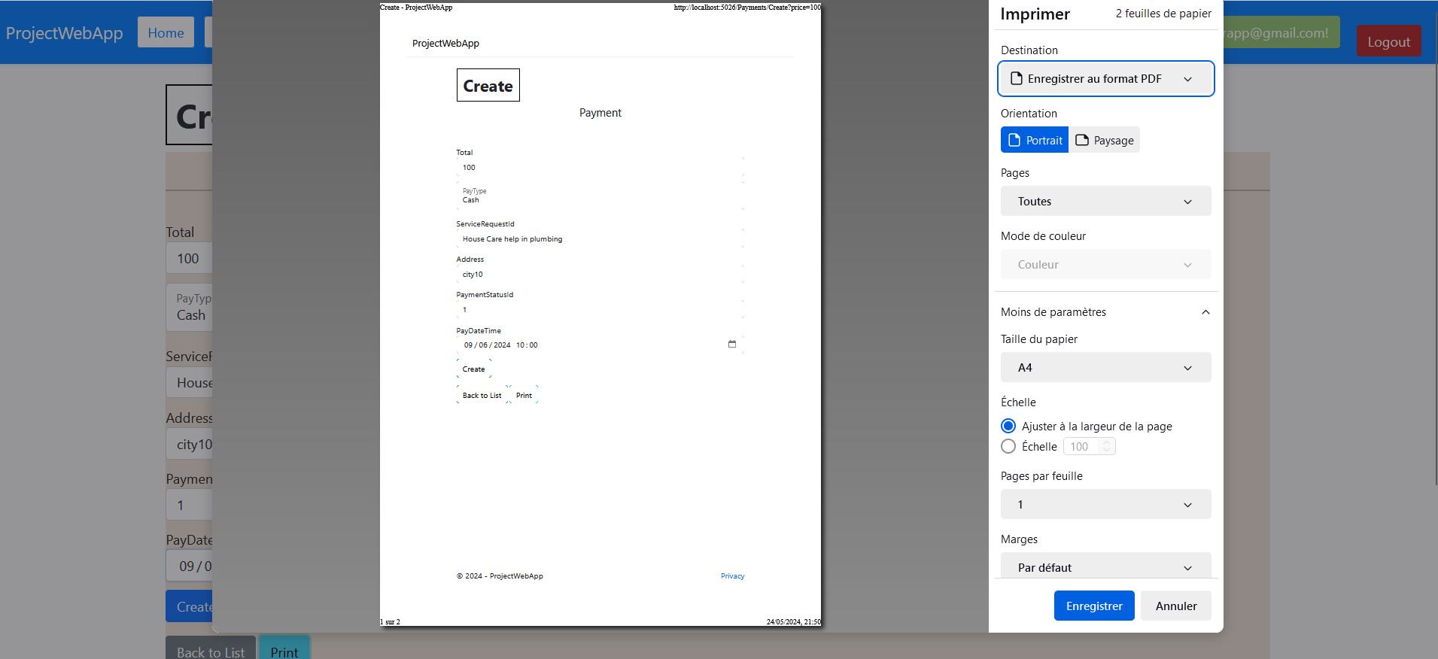

When user forgot his password, he can request it by this interface:

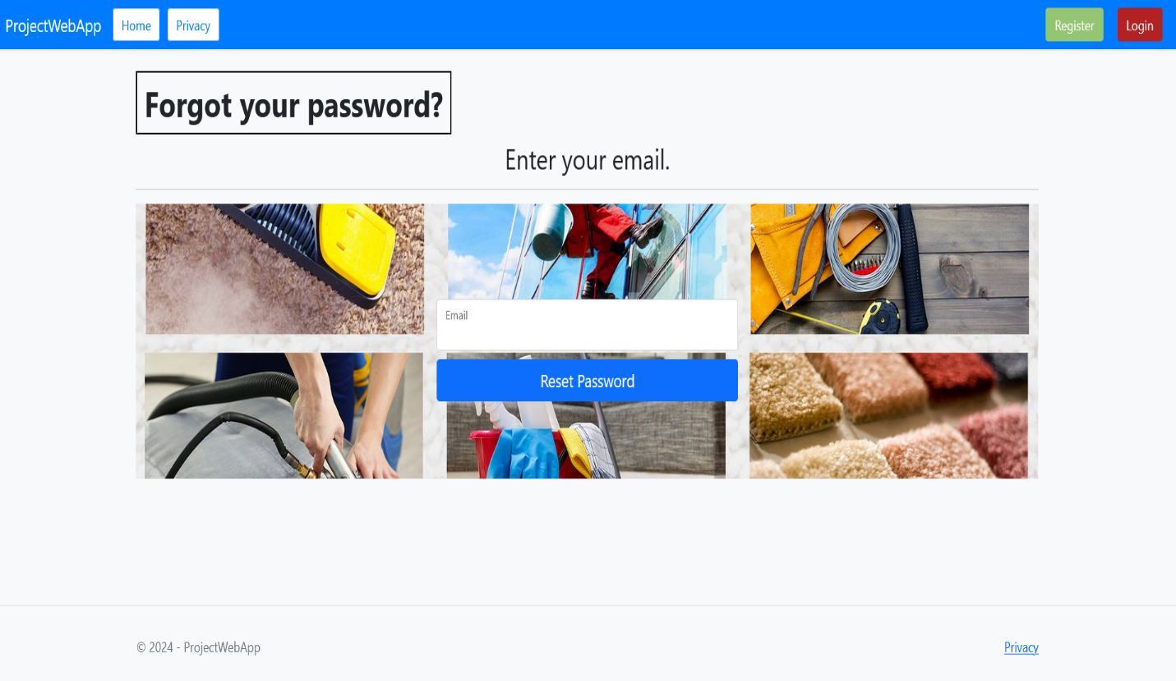

# Windows Form Application Documentation (w/ Screenshots)

We will start with the Login Interface that propose two different ways by role and a bouton to logout from the application, like this:

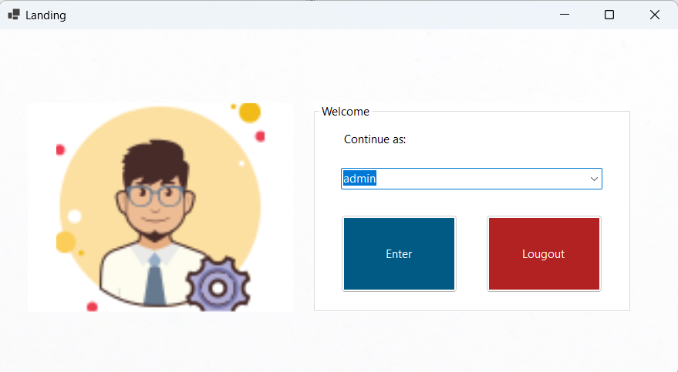

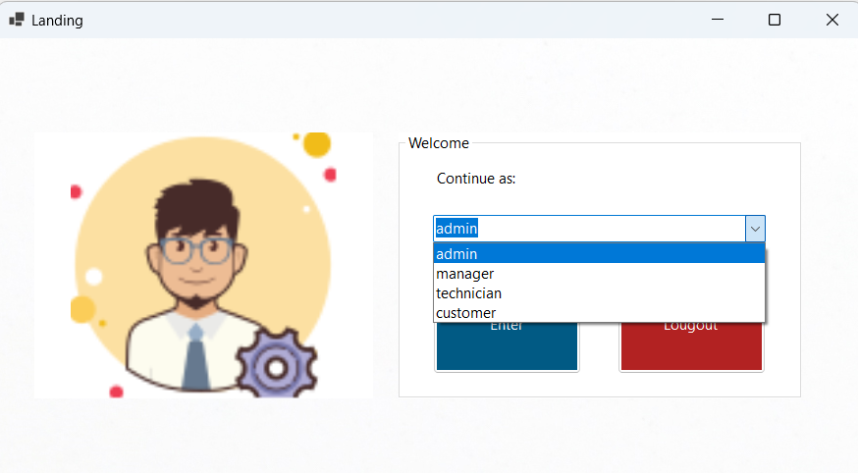

When we choose technician or customer, it shows an error message since it is an administrative application only for the admin and manager role.

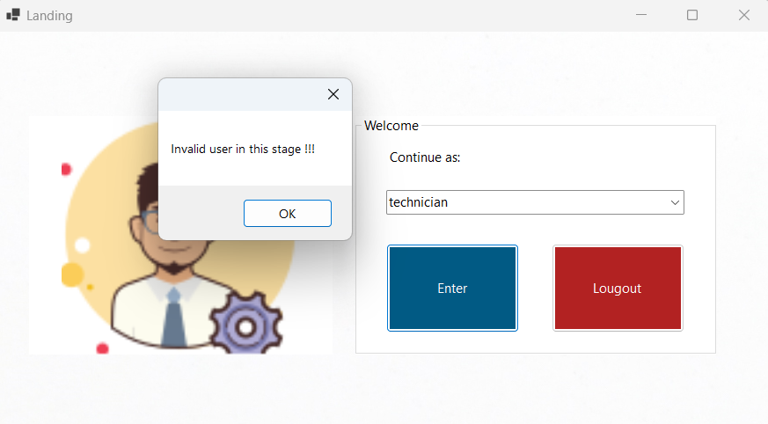

Now we will choose manager, so the page login for him is like:

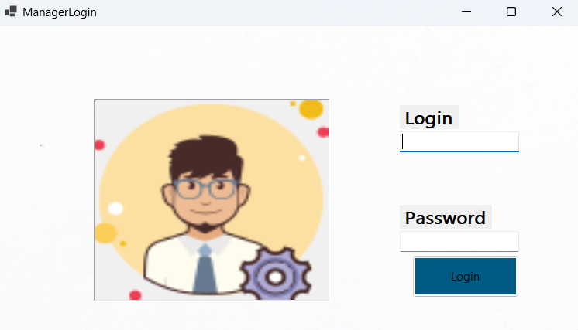

The manager will put his confidential data to move to his dashboard, so we will try with non-valid login and password to obtain this error:

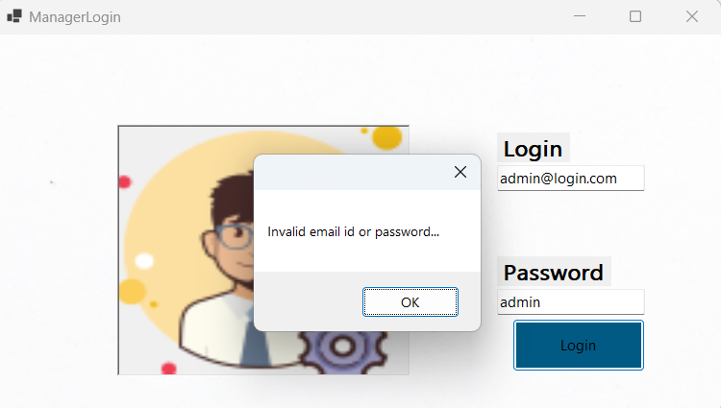

Also, when the fields are good, it shows the success message:

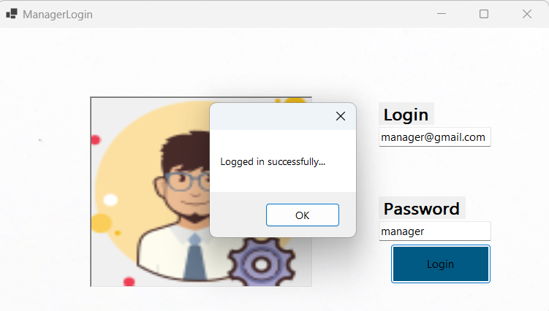

When, we click the button “**OK**”, the dashboard will be shown:

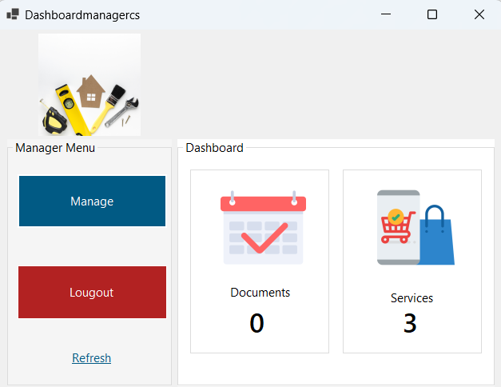

The manager can show the number of services in the system and the number of documents, he can click the button “**Logout**” return the first page, and he can click manage to pass to the services interface.

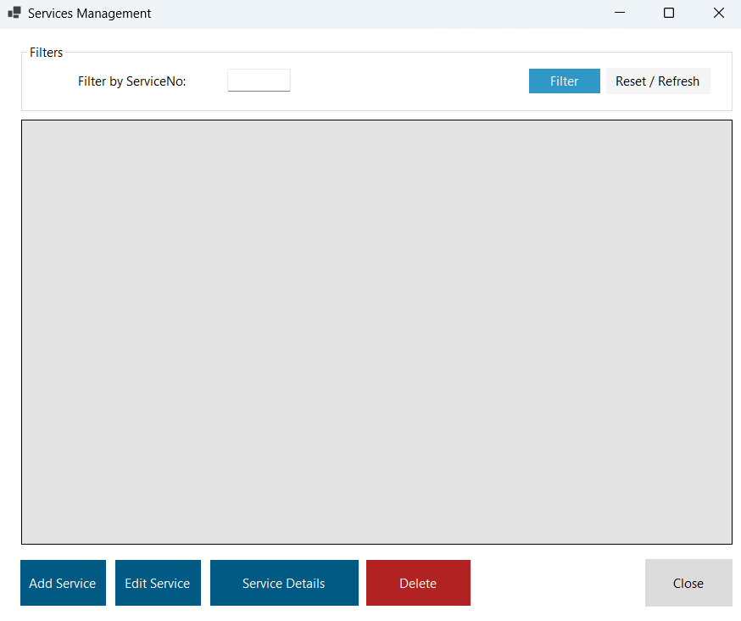

He can here add service, edit of delete service, and select service to show it details with the possibility of filtering list of service using Service Number.

By clicking “**Close**” and return to the manager dashboard, we can click another “**Logout**” to move to the Landing page.

Here we ca do a second scenario but with the admin role.

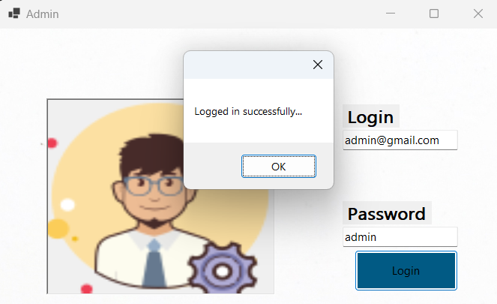

When we click “**OK**”, we will be redirected to the Admin Dashboard.

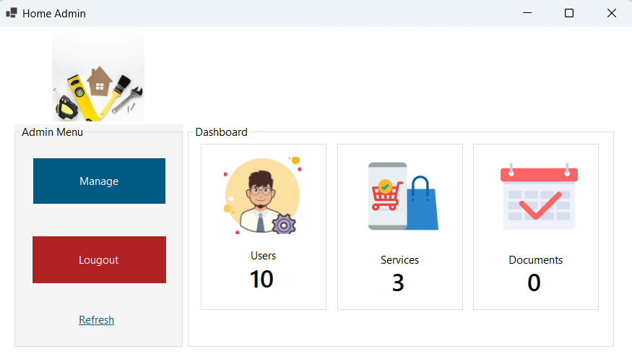

This dashboard contains the number of users that is not show in the manager dashboard, for the “**Logout**” and “**Manage**” buttons, they have the principle like those of manager.

# Supporting videos link

Windows Form Application:-

<https://www.youtube.com/watch?v=q8KYgPqJaBQ>

Web Application:-

<https://youtu.be/IijTeFvqudo>